Introduction to Cryptography

Cipher 1: Grid Cipher

Directions: The grid below maps English letters to coordinates. Use the grid to translate the Ciphertext into English. Hint: The first number in each pair is the column number.

 | 1 | 2 | 3 | 4 | 5
1 | A | B | C | D | E
2 | F | G | H | I/J | K
3 | L | M | N | O | P
4 | Q | R | S | T | U
5 | V | W | X | Y | Z

Ciphertext: 3 4 5 1 1 5 5 1 3 3 4 4 4 5 4 3 3 3 5 1
S E V E N T Y O N E

Cipher 2: Caesar Cipher

Directions: The Caesar cipher is one of the most widely known encryption techniques. It is a substitution cipher where each letter in the plaintext is replaced by a letter some fixed number of positions down the alphabet. Use the frequency graphs below to answer the questions. Then use the table to translate the Ciphertext into English.
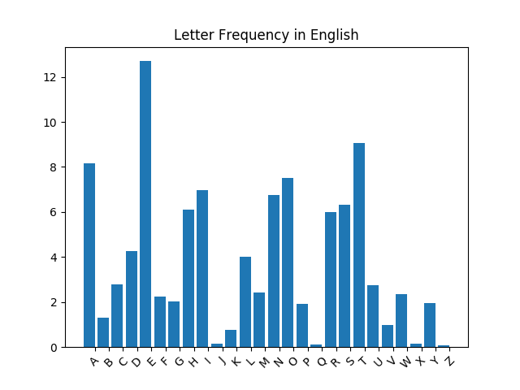
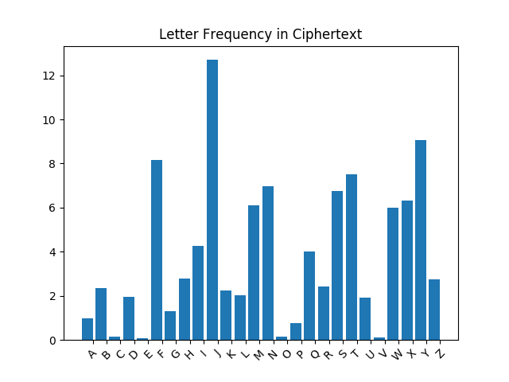

- Which letter in the English text maps to the letter J in the cipher text? __E___
- How many letters away is J from your answer to question 1? __5___

- Write out the new cipher text alphabet by shifting every letter by the answer to question two.
Ciphertext Alphabet | A | B | C | D | E | F | G | H | I | J | K | L | M | N | O | P | Q | R | S | T | U | V | W | X | Y | Z
English Alphabet | V | W | X | Y | Z | A | B | C | D | E | F | G | H | I | J | K | L | M | N | O | P | Q | R | S | T | U

- Use the mapping between the ciphertext alphabet and the English alphabet to decrypt the ciphertext below.
Ciphertext: YMNWYDKTZW

THIRTYFOUR

Cipher 3: Columnar Transposition

Directions: In columnar transposition, the message is written in rows of a fixed length. This length can be any number. Our length is 7. Write the Ciphertext into rows, then the columns can be read to reveal the message.

Ciphertext: TWUNINEHEETSTNERSHSYQATTRESENOIEVERSQOEEVA

Start here

T W U N I N E
H E E T S T N
E R S H S Y Q
A T T R E S E
N O I E V E R
S Q O E E V A

Find the answer by reading the columns

Cipher 4: PigPen Cipher

Directions: The pigpen cipher is a geometric substitution cipher where letters are replaced with symbols. The key below provides a mapping of letters to symbols. Use the key to translate the Ciphertext into English.

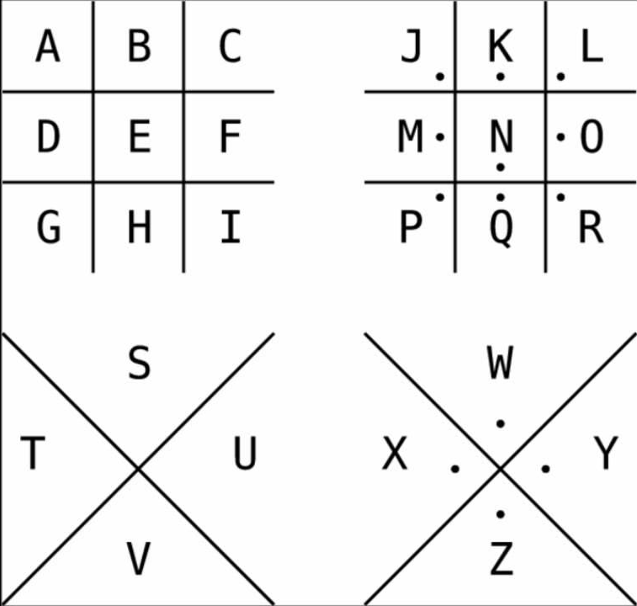
Key:

Ciphertext:

Answer: T H E A N S W E R I S T W O

